1. First use it should [assign permissions](http://www.baidu.com/link?url=B0u4HRve4-KfLP-RARDGhyT8Dlh6c--tmsX_Ezpe0MVGcmmAp6C-JzU-nI-wlXhgCytzj-DE79H93T_Z6PjoXL5RRLSww1kEFzDWrEbzN-SKVtvq0aDcPP-z_1ss4Ggk);

Connect usb line to raspberry . then open Control

Type lsusb

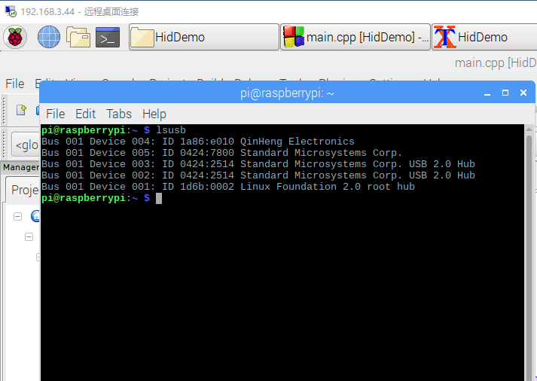

You can find ID 1a86:e010 QinHeng Electronics

Then [assign permissions](http://www.baidu.com/link?url=B0u4HRve4-KfLP-RARDGhyT8Dlh6c--tmsX_Ezpe0MVGcmmAp6C-JzU-nI-wlXhgCytzj-DE79H93T_Z6PjoXL5RRLSww1kEFzDWrEbzN-SKVtvq0aDcPP-z_1ss4Ggk);

Then Type sudo vi /etc/udev/rules.d/10-my-usb.rules

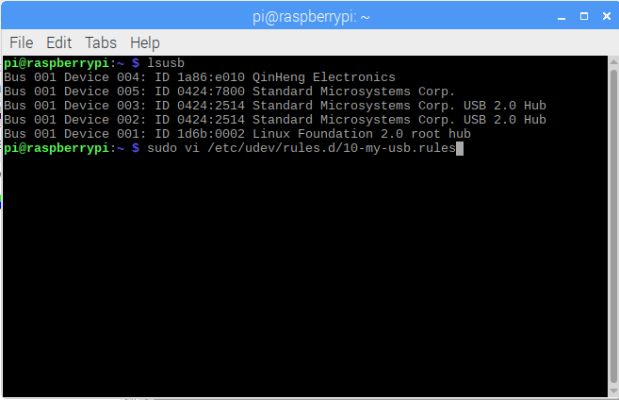

Then type

SUBSYSTEM=="usb",ATTRS{idVendor}=="1a86", ATTRS{idProduct}=="e010", MODE="666", GROUP+="plugdev"

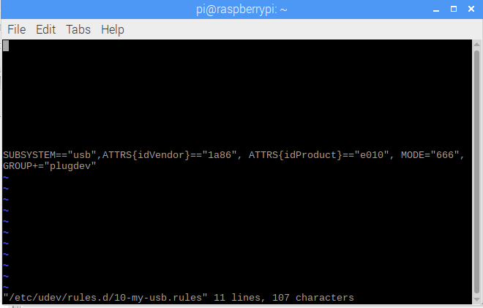

Then type :wq

Then **sudo** udevadm trigger

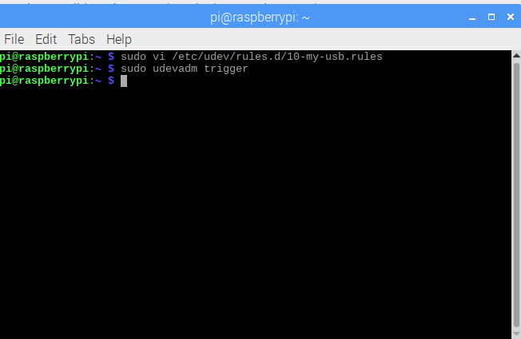

OK. Then you can use usb hid interface

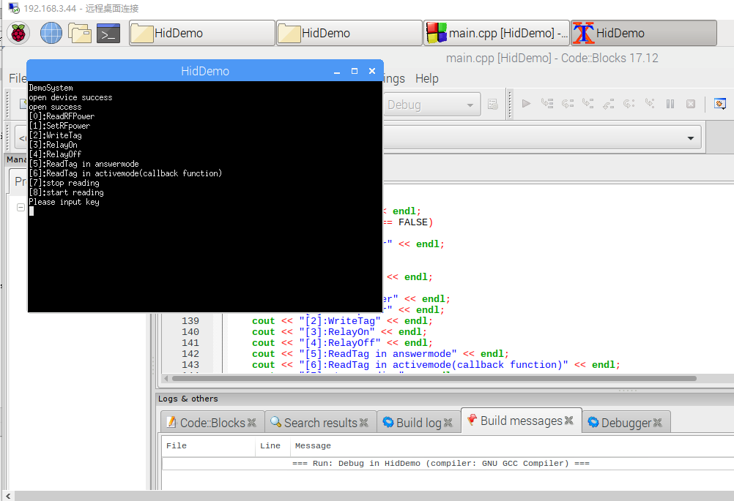

The code base on Code blocks